This folder is your team’s project governance portfolio folder.

At the time of provision, you’ll see three items already added to the folder:

* **(Shortcut) _Sample of Project Governance Portfolio (UGIE)**This shortcut will redirect you to a read-only PGP sample
* **(Folder) _Trash**This folder is created for you in case you cannot delete files within your PGP folder - you can put them inside this folder and the unit staff can delete them for you
* **(Document) _Use the above PGP sample folder to create your own structure, right here, in this folder_**  
  This file/Google Doc you’re reading right now.

To setup your PGP folder for upcoming project:

1. Identify the PGP folder - The folder shared with you is the PGP folder.   
   **Not** the sample
2. Open the sample PGP shortcut, and download the sample PGP into a zip file:  
   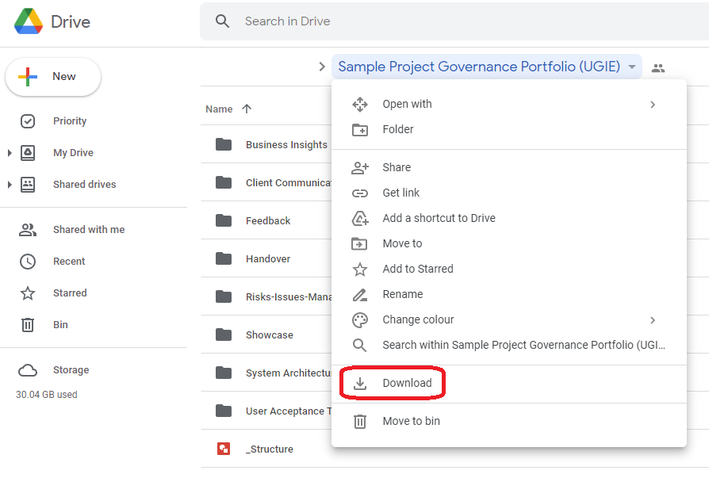
3. Unzip the downloaded file, and re-upload those files into your PGP folder. Once done it’s probably gonna look like this:  
   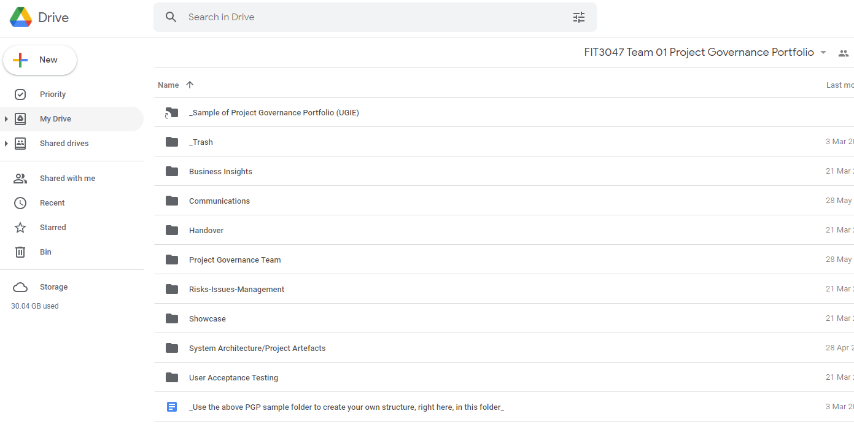
4. Follow the instructions from your studio mentors to add/modify/remove files/folders to make it work
5. (Optional but recommended) create a shortcut or star/favourite the PGP folder so it’s easier to access in the future

**If you have any questions, please contact your studio mentors.**